#Multistage Dockerfile Theory
In simple words, a multi-stage build in Docker is a technique used to create smaller and more efficient Docker images. Instead of building a single Docker image with all the dependencies and tools needed for an application, a multi-stage build involves creating multiple stages in the Docker file, each serving a specific purpose.
The first stage, known as the "build" stage, is used to compile, build. and gather all the necessary files for the application. This stage might include installing dependencies, compiling code, and collecting artifacts.
The subsequent stages, often referred to as the "runtime" stages, take only the essential files from the build stage needed to run the application. These stages exclude unnecessary build tools and dependencies, resulting in a smaller and more streamlined final image.
The key advantage of multi-stage builds is that they help reduce the overall size of the Docker image, making it more efficient for distribution and deployment. This can lead to faster image downloads, quicker deployment times, and lower resource consumption.

#Multi-Stage Dockerfile {ubuntu:22.04}

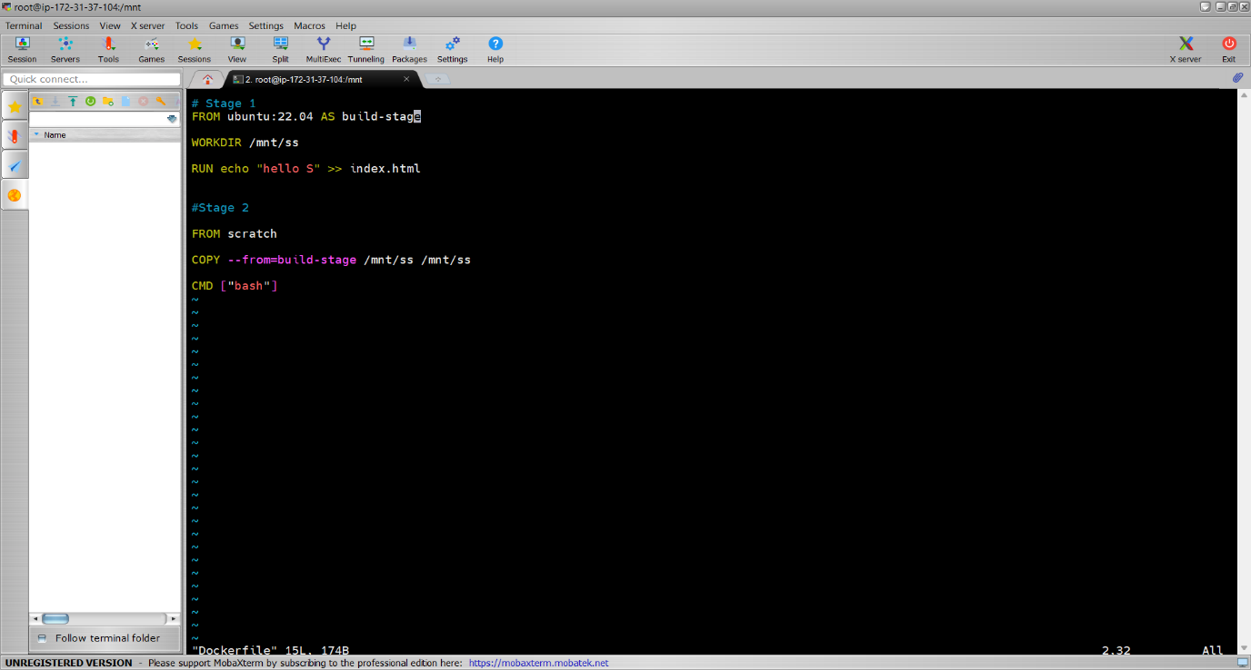

#Single Stage Dockerfile {ubuntu:22.04}

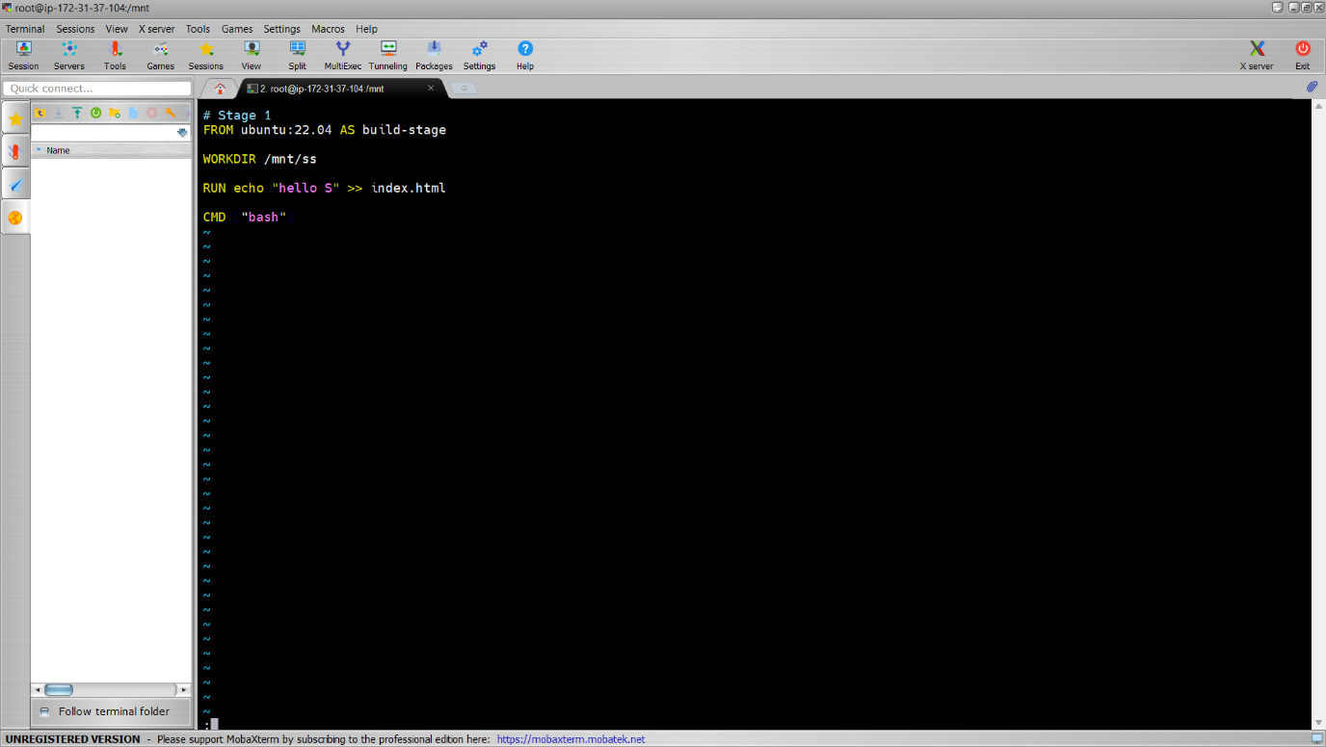

#Image Size Reduction {ubuntu:22.04}
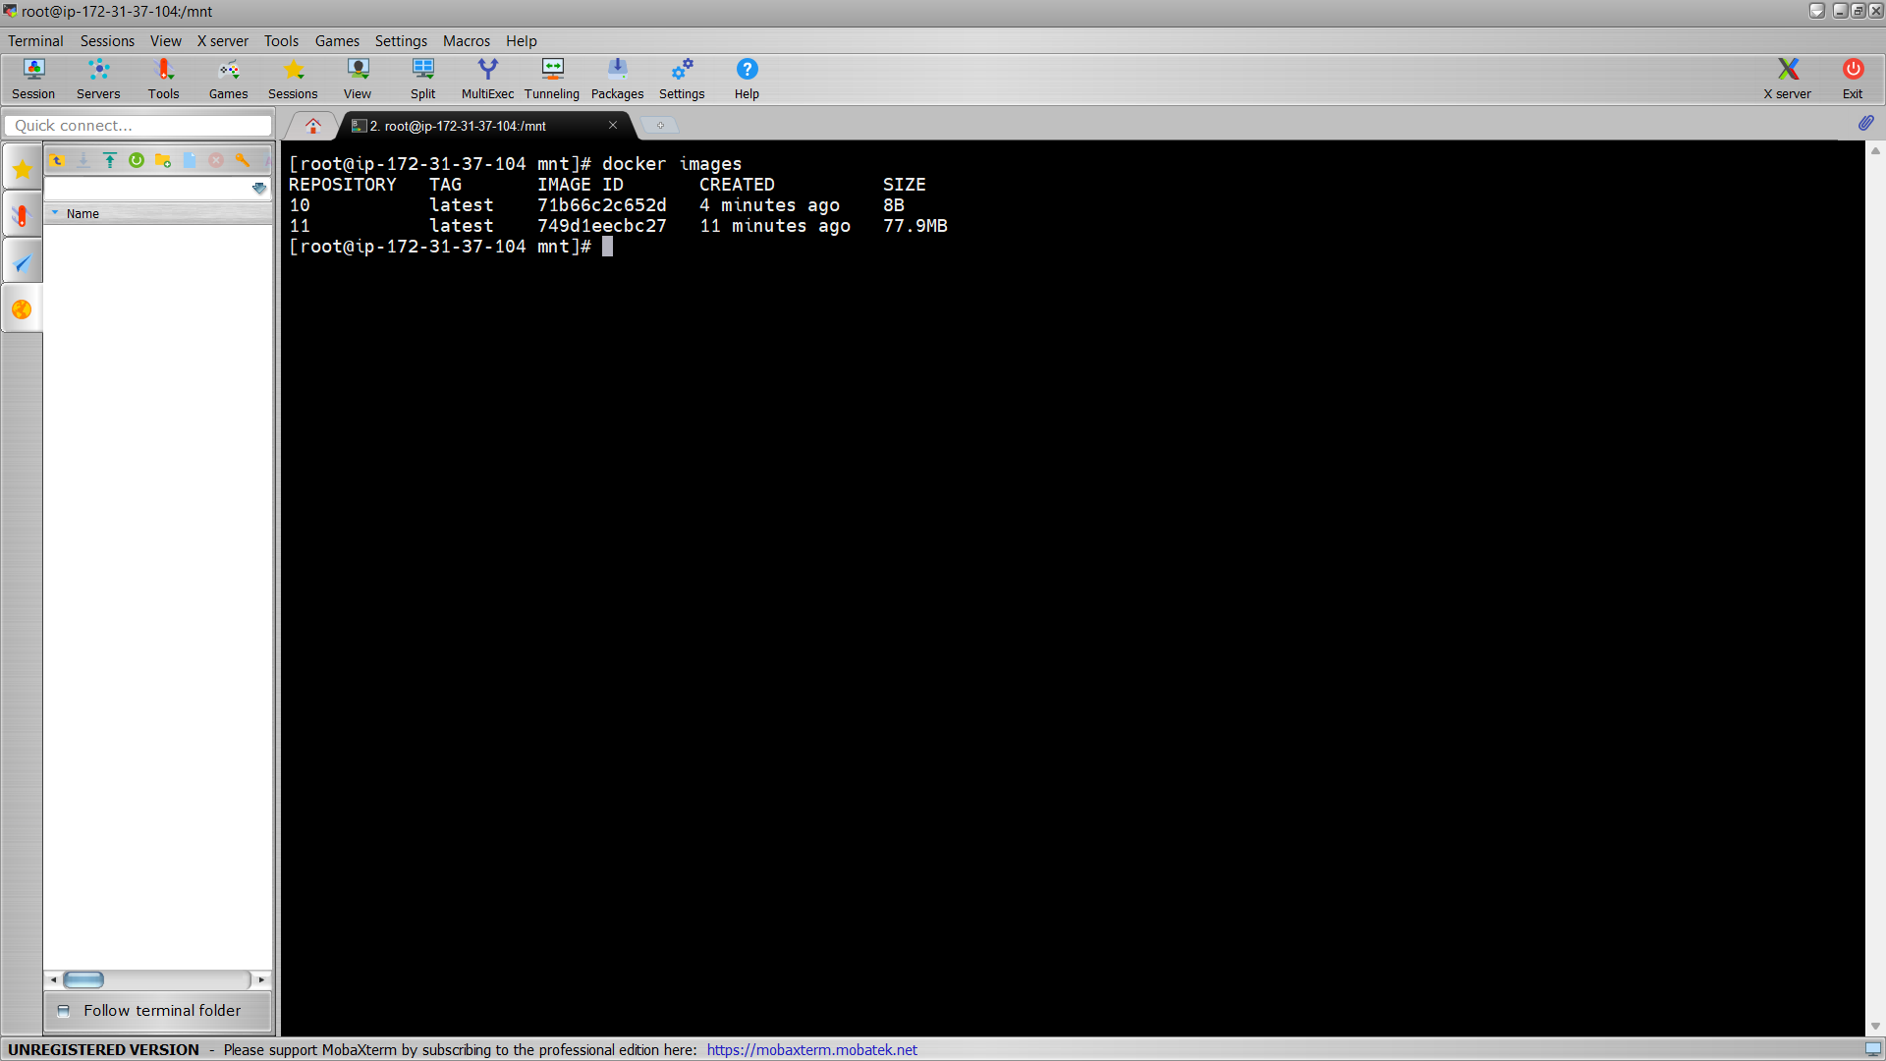

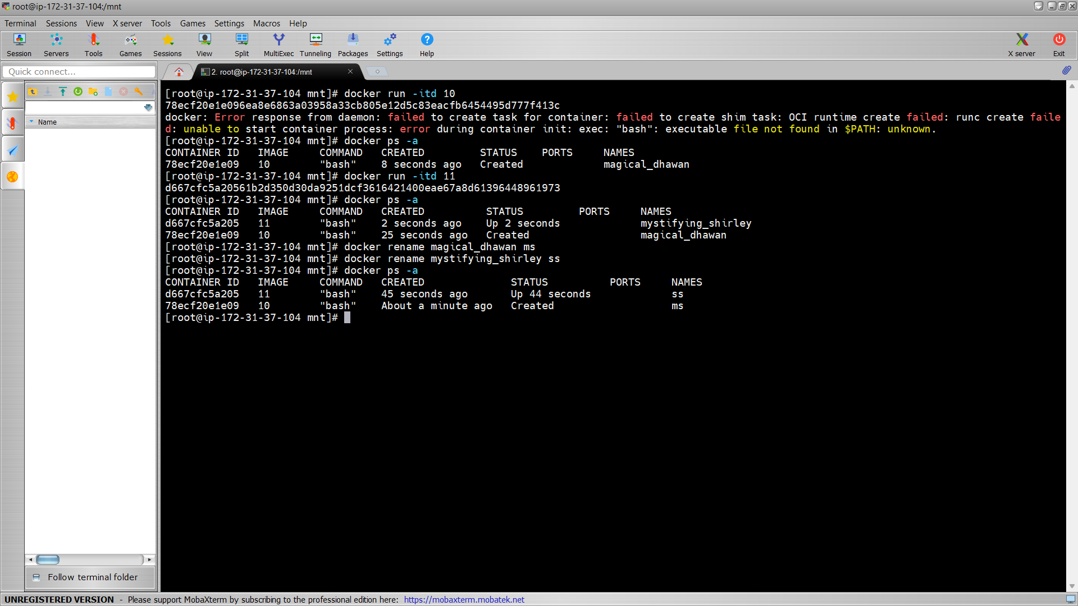

# Open-source tools used to check vulnerability of Docker file.
Docker Hardened Images (DHIs) are designed to be secure by default, but like any container image, it's important to scan them regularly as part of your vulnerability management process.
To get accurate vulnerability assessments, use scanners that support VEX attestations. The following scanners can read and apply the VEX statements included with Docker Hardened Images:
- Docker Scout: Automatically applies VEX statements with zero configuration
- Trivy: Supports VEX through VEX Hub or local VEX files
- Grype: Supports VEX via the --vex flag
- Wiz: Automatically applies VEX statements with zero configuration

